Federated Learning Based Heart Disease
Prediction Using a Secure Hierarchical Blockchain Aggregation
Abstract. Predicting heart disease accurately while protecting patient privacy is one of the biggest challenges in modern healthcare. Federated Learning (FL) addresses this by allowing hospitals and clinics to train a shared model without sharing raw data. However, FL can still face problems when some participants provide poor-quality updates, act maliciously, or try to benefit without contributing. To overcome these challenges, we propose a Hierarchical Blockchain–Enabled Secure Aggregation framework for federated heart disease prediction. Our system uses a layered blockchain to ensure training activity is transparent and tamper-proof, while a Proof-of-Quality (PoQ) mechanism evaluates the reliability of each update. A Bayesian reputation algorithm with time-based decay continuously tracks client trustworthiness, and smart-contract-like routines automate tasks such as registration, reputation posting, and participant selection. Finally, a Federated Random Forest ensemble combines models by weighting them according to reputation and fine-tunes thresholds for accuracy. Tests on heart-disease datasets show improved security, reliability, and privacy—critical for trustworthy healthcare AI.
Keywords: Federated learning · blockchain · secure aggregation · heart disease prediction · reputation management · Proof-of-Quality (PoQ).

Introduction
Artificial Intelligence (AI) is playing an important role in modern healthcare by turning medical data into useful insights that help doctors make faster, more accurate, and personalized decisions [3]. One of the most impactful areas where AI is applied is in predicting heart disease, since cardiovascular problems remain the leading cause of death worldwide [11]. Traditional machine learning methods trained in centralized systems have shown good results, but they require sensitive patient data to be collected and sent to a central server [13]. This not only raises concerns about privacy but also creates issues like high communication cost and delay [4].
Federated Learning (FL) has been introduced as a way to overcome these problems. Instead of moving all patient data to a single location, Federated Learning (FL) enables multiple hospitals and medical centers to collaboratively train models while keeping their data securely stored locally [3]. Only the model updates — not the raw patient information — are shared, which helps protect privacy while still supporting the development of accurate prediction models [13]. This approach is especially valuable in healthcare, where strict regulations, such as HIPAA and GDPR, limit how patient information can be exchanged across institutions [4].
Although Federated Learning (FL) addresses many privacy concerns, it still faces significant security challenges. Some participants may attempt to disrupt the process by submitting false or poisoned model updates, which can lower the accuracy and reliability of the final global model [5]. Such attacks raise concerns about how secure and trustworthy FL truly is in healthcare applications [8]. To overcome these risks, there is a need for secure aggregation techniques that not only combine model updates safely but also verify the credibility of each participant [7].
Despite the advantages of federated learning (FL) in preserving data locality, practical deployment in healthcare environments faces three unresolved challenges [12]. First, FL is vulnerable to unreliable or malicious participants that may submit noisy, low-quality, or strategically manipulated updates, significantly degrading global model performance [9]. Second, existing robust aggregation schemes often lack transparency and accountability, making post-hoc auditing of training behavior difficult in regulated medical settings [5]. Third, although blockchain has been adopted to enhance trust in federated learning, many existing approaches rely on monolithic blockchain designs that fail to clearly separate training coordination from auditability functions, ultimately resulting in scalability limitations [9].
To address these issues, this paper proposes a Hierarchical Blockchain–Enabled Secure Aggregation framework for federated heart disease prediction. Unlike prior FL–Blockchain systems that merely combine decentralized training with immutable logging, the proposed framework explicitly decouples training coordination from audit anchoring using a hierarchical blockchain design [8]. A Proof-of-Quality (PoQ) mechanism statistically validates local model updates prior to aggregation, while a Bayesian time-decayed reputation model dynamically evaluates client reliability across training rounds [7]. These components work together to selectively aggregate trustworthy updates based on reputation, thereby enhancing robustness in the presence of heterogeneous and unreliable healthcare data sources [9].
Importantly, this work does not claim blockchain-based confidentiality, but instead leverages blockchain strictly for integrity, traceability, and accountability, aligning with its cryptographic guarantees. Through formal robustness modeling and adversarial evaluation, this work demonstrates that the proposed framework not only improves model accuracy but also introduces a novel causally linked trust pipeline — Proof-of-Quality → Bayesian reputation → reputation-weighted aggregation → blockchain auditing. To the best of our knowledge, no existing FL-Blockchain framework integrates statistical quality gating and dynamic trustdriven secure aggregation validated under multiple adversarial threat scenarios. The main contributions of this work are as follows:

Hierarchical Blockchain–Anchored FL Architecture
We propose a two-tier blockchain design that clearly separates federated training coordination from immutable audit anchoring. In this architecture, lightweight sidechains are responsible for managing client participation, model update submission, and aggregation coordination, while the mainchain is used exclusively to record essential audit information. This design choice reduces blockchain-related overhead while preserving traceable and tamper-evident training records.

Proof-of-Quality (PoQ)–Based Update Validation
A statistical Proof-of-Quality (PoQ) mechanism is incorporated to evaluate the reliability of client model updates before aggregation. By analyzing update consistency and performance deviations, the PoQ module identifies and filters low-quality or anomalous updates, thereby preventing them from negatively affecting the global model.

Bayesian Time-Decayed Reputation Mechanism
To dynamically capture client reliability, a Bayesian reputation model with temporal decay is introduced. Client trust scores are continuously updated across training rounds, allowing recent behavior to have greater influence than outdated contributions. This approach enables resilient aggregation in the presence of noisy or unreliable participants.

Reputation-Weighted Federated Random Forest Aggregation
Building on the reputation mechanism, a reputation-weighted aggregation strategy for federated Random Forest models is proposed. Client updates are weighted by trust scores, improving robustness and predictive performance under heterogeneous medical data distributions.

Literature Review
Y. Chen et al., proposed a secure hierarchical asynchronous federated-learning scheme that integrates mask-based differential privacy with a Byzantine-resilient consensus layer. The architecture targets IoT settings by protecting client updates and mitigating Byzantine failures; experiments on standard image benchmarks and a heart-disease dataset showed faster convergence and modest accuracy gains. The method improves robustness and privacy but increases communication and orchestration complexity due to the multi-layer consensus and masking overhead [5].
P.G. Shynu et al., developed a blockchain-enabled fog computing pipeline for diabetic and cardio disease prediction. Patient records are clustered with a rule-based clustering algorithm and then classified using feature-selection-driven ANFIS (FS-ANFIS). The approach leverages fog nodes for low-latency preprocessing and a consortium blockchain for provenance. It attains respectable classification accuracy on real-world health records, but is semi-centralized, limited to a small set of disease classes, and sensitive to feature-selection choices [18].
A. Lakhan et al., designed a federated, blockchain-enabled framework for IoMT task scheduling (FL-BETS). The model focuses on privacy-preserving scheduling across fog/cloud nodes, reducing latency and energy in IoMT workloads. While it effectively balances timeliness and security, the scheduling heuristics and blockchain interactions add management overhead in heterogeneous deployments
[12].
S.M. Rajagopal et al., proposed FedSDM, a federated learning-based smart decision-making module for ECG data in IoT-enabled Edge–Fog–Cloud environments. The framework integrates microservices with FL to preserve patient privacy while enabling real-time anomaly detection. By deploying the module across Edge, Fog, and Cloud layers, the study highlights that Edge-based placement achieves superior performance in latency, energy, cost, and execution time. Although effective in enhancing privacy and responsiveness, the system introduces added complexity in managing microservices and federated aggregation across heterogeneous layers [14].
H. Elayan et al., developed a deep federated learning (DFL) pipeline for skindisease detection on IoT devices, demonstrating high AUCs while preserving data locality. Their approach underlines FL’s performance on imaging tasks but highlights constraints from intermittent connectivity and device compute limits when on-device training is required [6].
N. Rieke et al., authored a forward-looking survey of federated learning in digital health, synthesizing evidence across EHRs, medical imaging, and genomics. They highlight FL’s ability to overcome data silos but caution about fairness, gradient leakage attacks, and integration complexity with clinical workflows [17].
R.S. Antunes et al., reviewed federated learning for EHRs and found FL can match or surpass centralized accuracy when properly aggregated, but aggregation methods remain vulnerable to bias and heterogeneity; the review emphasizes the need for robust aggregation and auditing mechanisms [3].
J. Soni et al., examined traditional predictive-data-mining techniques for heartdisease diagnosis (Decision Trees, Naïve Bayes, KNN, Neural Networks) and showed that classical models with thoughtful feature selection and ensembles can still yield strong baselines. The work is useful as a comparator for newer federated/decentralized architectures [11].
H. Fereidooni et al., proposed SAFELearn, a secure aggregation method using secure multiparty computation for FL that defends against inference attacks during aggregation. SAFELearn is efficient for many-party aggregation but does not fully address poisoning or backdoor attacks originating from malicious clients [7].
S. Aich et al., presented a blockchain–federated-learning framework for protecting personal healthcare records, leveraging smart contracts for access control and audit trails. The integration provides transparency and traceability but introduces transaction costs and potential latency [2].
In summary, prior works highlight three major trends: federated learning improves privacy but requires stronger robustness guarantees to handle unreliable or malicious participants; blockchain enhances transparency and accountability but adds cost and latency; and hybrid schemes that integrate secure aggregation, trust evaluation, and blockchain show promising potential but must be carefully designed to maintain scalability and practicality. These observations motivate our proposed hierarchical blockchain-enabled secure aggregation framework for federated heart disease prediction.

System Architecture and Hierarchical Design
The proposed system comprises four logical layers—Client, Aggregation, Blockchain, and Deployment. At the client layer, each participating healthcare institution locally stores its electronic health records (EHRs) and trains a Random Forest model on private data, transmitting only encrypted model updates and associated validation metrics. The aggregation layer consists of regional aggregators that coordinate federated training rounds by performing Proof-of-Quality (PoQ) validation and reputation evaluation to filter unreliable or low-quality updates before aggregation. The blockchain layer employs a hierarchical structure in which lightweight sidechains record client registration events, PoQ verification outcomes, and dynamic reputation updates, while a mainchain anchors cryptographic Merkle roots of aggregated model updates to provide immutable and tamper-evident auditability without storing sensitive parameters. Finally, the deployment layer redistributes the aggregated global model to participating clients for inference and subsequent training iterations until convergence. This hierarchical separation of responsibilities reduces blockchain consensus overhead while preserving transparency, accountability, and traceability throughout the federated learning process.

Proposed Work
The proposed framework enables privacy-preserving heart disease prediction by integrating Federated Learning (FL) with Hierarchical Blockchain-enabled secure aggregation and Reputation Management. Sensitive patient data remains local at client sites, and only encrypted model updates are shared. This ensures tamper-proof aggregation of high-quality updates into a global heart disease prediction model [11].
Fig. 1 illustrates the overall workflow of the proposed Hierarchical BlockchainEnabled Secure Aggregation framework for federated heart disease prediction. The process begins with data acquisition from multiple healthcare institutions, where sensitive patient records remain stored locally to preserve privacy. In the data preprocessing stage, missing values are handled, categorical features are encoded, and data is normalized for consistency [8]. The hierarchical blockchain layer then coordinates federated training while maintaining transparent and tamper-proof records of participation. The Proof-of-Quality validation process and reputation management work together to ensure that only trustworthy client updates are included in the secure aggregation step. Once combined, the final global model is recorded on the blockchain and then deployed to enable accurate and privacy-preserving heart disease prediction [13].

Phases of the Proposed Framework
The proposed heart disease prediction framework has following phases (Fig. 1). In the Data Acquisition Phase, patient health records are gathered from multiple healthcare institutions, including demographic, clinical, and lifestyle factors like age, blood pressure, cholesterol, ECG results, and smoking status. For evaluation, two standard datasets are used: the UCI Heart Disease dataset (303 records, 13 clinical features) and the Framingham Cardiovascular Study dataset (4,240 records, 15 attributes predicting 10-year CHD risk) [4].
The Preprocessing and Dataset Construction Phase prepares raw data for training by imputing missing values, encoding categorical variables, and normalizing features to avoid bias. Stratified sampling is then used to create balanced training, validation, and test sets while maintaining the original class distribution [10].
The Feature Engineering Phase enhances model accuracy and interpretability by creating derived risk factors (e.g., cholesterol ratios) and performing featureimportance analysis to identify key medical predictors, ensuring the model is both accurate and clinically understandable [10].
The Federated Training and Reputation Management Phase trains local Random Forest models at each client site, sharing only model updates. These updates are validated using a Proof-of-Quality (PoQ) check against median client accuracy.
A Bayesian reputation system with time-decay adjusts trust scores—rewarding reliable contributors and penalizing poor or malicious updates. Only clients above a set reputation threshold join secure aggregation [8].
The Proof-of-Quality validation mechanism and the Bayesian time-decayed reputation model are formally expressed through the following mathematical representations.

Proof-of-Quality and Reputation Modeling
A Proof-of-Quality (PoQ) check is performed against the median client accuracy to filter low-quality or malicious updates. A Bayesian reputation system with time
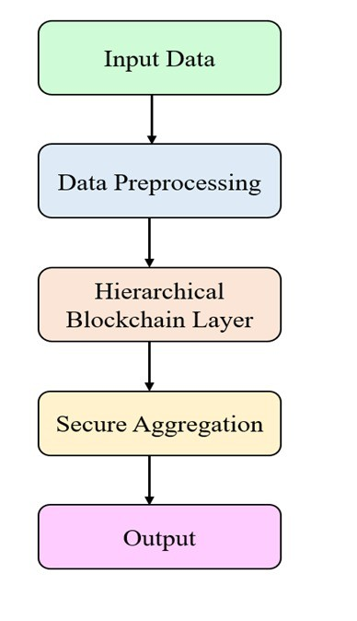
Fig.1. Workflow of Hierarchical Blockchain-Enabled Secure Aggregation
decay dynamically adjusts client trust scores by rewarding reliable contributors and penalizing poor updates. Only clients whose reputation exceeds a predefined threshold are allowed to participate in secure aggregation.
Let W_{i}^{t} denote the local model update submitted by client i at round t. Each update is evaluated on a shared validation subset to compute a quality score Q^{t}_{i}. An update satisfies the Proof-of-Quality (PoQ) constraint if
Q^{t}_{i} ≥ µ_{t} − δ, (1)
where µ_{t} represents the median validation score across all participating clients and δ is a tolerance threshold controlling acceptable deviation.
Client reputation is updated using a Bayesian time-decayed model given by
Rit+1 = αRit + (1 − α)Qti, (2)
where α ∈ [0,1] determines the influence of historical behavior relative to recent update quality.
Finally, the global model is aggregated using reputation-weighted averaging as
P RtWt t+1 i∈K i i
W = P t , (3)
i∈K _{Ri}
where K denotes the set of top-K reputed clients selected for secure aggregation.
Algorithm 1: Federated Blockchain Heart-Disease Prediction Input: Local model updates and validation metrics from clients
Output: Reputation-weighted global heart-disease model
Step 1: Register clients on sidechains via smart contracts.;
Step 2: Clients train local models on private data and compute validation metrics.;
Step 3: Apply Proof-of-Quality (PoQ) check and update client reputations using Bayesian time-decayed scoring.;
Step 4: Aggregate top-_{K} reputed updates securely and anchor Merkle roots on the mainchain.;
Step 5: Deploy the global model for inference; repeat training and aggregation until convergence.;

Fig 2 illustrates the stepwise process of the proposed hierarchical blockchainenabled federated learning system. Initially, hospitals or healthcare nodes register on sidechains through smart contracts to ensure trusted participation. Each registered client trains a local model using its own private patient data without sharing raw records. After training, updates are verified through a Proof-ofQuality (PoQ) mechanism and client reputations are updated using a Bayesian time-decay strategy to fairly weigh reliable contributions [7]. Only the top-K reputed updates are selected for secure aggregation, where they are combined
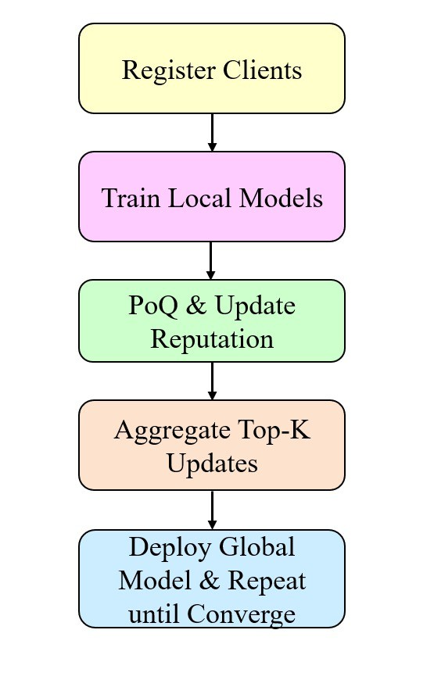
Fig.2. Proposed Federated Model Training and Aggregation Process
into a new global model and anchored to the main blockchain for tamper-evident auditability. This iterative cycle continues until the global model reaches stability or a predefined convergence criterion, ensuring accuracy, robustness, and data privacy [12].
Proposed Algorithm Figure 3 presents the stepwise operational flow of the proposed federated blockchain framework for secure and privacy-preserving heartdisease prediction. The process is organized into five major phases, each designed to ensure data confidentiality, model reliability, and resilience against malicious contributions while enabling collaborative training across distributed healthcare institutions [8].
The process begins with the Register Clients phase, where healthcare entities such as hospitals, diagnostic laboratories, and clinics are enrolled into the federated learning (FL) network. Participant registration is managed through blockchain-based smart contracts, which verify the authenticity of each participant and enforce access control policies, ensuring that only authorized and accountable institutions can contribute to model training while maintaining a tamper-evident record of participation [11].
After registration, each client enters the local model training stage, where institutions use their private electronic health records (EHRs) to train machine learning models without transferring sensitive patient data to a centralized server. This design preserves confidentiality, complies with strict regulations such as HIPAA and GDPR, and enhances the diversity of the global model by incorporating real-world data from multiple healthcare environments [4].
Once local training is complete, the Proof-of-Quality (PoQ) Update Reputation step safeguards the system by validating each client’s submitted model parameters or gradients for consistency and predictive quality against defined performance thresholds. At the same time, a dynamic reputation score is assigned using a time-decayed Bayesian method, rewarding recent high-quality contributions while reducing the influence of older or unreliable updates, thereby discouraging adversarial behavior and encouraging trustworthy participation [5].
During the Aggregate Top-K Updates phase, only the highest-reputation clients’ updates are selected to build the next global model, improving both reliability and performance by excluding poor-quality or malicious contributions [16]. The aggregation process itself is secured through cryptographic Merkle roots anchored on the blockchain, creating an immutable and auditable record of each training round without revealing sensitive data, which strengthens security and accountability [15].
Finally, the Deploy Global Model — Repeat Until Convergence stage redistributes the updated global model to participating clients, who continue refining their local models and submitting new updates until the system reaches optimal accuracy and stability. This iterative loop continues until the model reaches convergence, defined by stability in validation loss, predictive accuracy, or other performance metrics. Once convergence is achieved, the resulting global model is ready for deployment in clinical applications, supporting early detection and risk assessment of heart disease across healthcare institutions [12].
The figure shows a secure and collaborative learning process, starting with client onboarding and moving to model refinement. Reputation scores and tamperproof records help maintain trust and reliability. Each step is designed to protect privacy, resist attacks, and keep the process transparent. This makes the framework well suited for real-world medical AI use [9]. Algorithm 2 presents the procedure for secure aggregation of federated updates.

Blockchain Role Clarification
Blockchain is employed strictly to ensure integrity, traceability, and non-repudiation of the federated learning process, and it is not used to provide confidentiality of patient data or model parameters [3]. Data privacy is preserved through federated learning, as raw medical records remain localized at client institutions and are never transmitted [18]. The blockchain layer maintains an immutable audit trail of client participation, reputation updates, and aggregation outcomes, enabling accountability and post-hoc verification in regulated healthcare environments [2]. Cryptographic secure aggregation mechanisms, such as secure multiparty computation (MPC) or homomorphic encryption, are beyond the scope of this study and are identified as important directions for future work [17]. This design choice aligns blockchain utilization with its inherent cryptographic guarantees while avoiding over-claiming privacy protection beyond what the system provides [6].
Algorithm 2: Secure Aggregation of Federated Updates
Input: Local model updates from top-_{K} reputed clients, client reputations
Output: Aggregated global model
Step 1: Collect encrypted updates from top-_{K} reputed clients.;
Step 2: Verify updates against Proof-of-Quality thresholds and reputations.;
Step 3: Perform reputation-weighted secure aggregation (weighted averaging of client updates).;
Step 4: Anchor aggregation results and Merkle root on the mainchain for auditability.;
Step 5: Return the aggregated global model for deployment to clients.;

Results & Comparison

Experimental Setup
Experiments were conducted in Python using Scikit-learn to simulate federated learning across 25 hospitals, with 3 malicious clients injecting noisy updates. Training proceeded for 8–12 communication rounds, where local models were aggregated into a global model using a reputation-weighted mechanism. Client reputations were dynamically updated based on reliability, ensuring robust aggregation. After each round, the updated global model was anchored to the blockchain using a Proof-of-Quality (PoQ) consensus protocol to guarantee integrity and tamper resistance. This setup allowed evaluation of both model performance and the framework’s ability to detect and mitigate adversarial contributions effectively.

Dataset Information
The performance of the proposed federated blockchain-based framework was rigorously evaluated using two widely recognized benchmark data sets for the prediction of heart disease. These datasets are frequently employed in cardiovascular risk modeling research and provide a strong basis for comparative analysis of predictive methods.
– UCI Heart Disease Dataset: This dataset comprises 303 patient records, each characterized by 13 clinical and demographic attributes, including age, sex, resting blood pressure, serum cholesterol, fasting blood sugar, resting electrocardiographic (ECG) results, maximum heart rate achieved, exerciseinduced angina, and ST depression. The dataset is primarily utilized for binary classification tasks, aiming to predict whether a patient is at risk of developing heart disease. Although relatively modest in size, it is widely recognized in academic and clinical research due to its well-balanced feature set and its strong relevance to early-stage cardiac risk assessment.
Both datasets contain a mixture of numerical features (such as cholesterol levels and resting heart rate) and categorical attributes (such as gender, smoking status, and presence of angina). To ensure model robustness and fairness, several data preprocessing steps were performed:
Missing-value imputation to handle incomplete patient records and avoid data loss.
Categorical-to-numerical encoding (e.g., one-hot or label encoding) to transform non-numeric attributes into machine-readable format. Feature scaling (standardization or normalization) to ensure attributes with larger numeric ranges, such as cholesterol or blood pressure, do not disproportionately influence the model training process. For experimental evaluation, both datasets were partitioned into training, validation, and testing subsets with a ratio of 70% : 1% : 15%. The training set was used to fit the local models at each federated client, while the validation set guided hyperparameter tuning and early stopping to avoid overfitting. The testing subset remained strictly unseen during training and was used to provide an unbiased estimate of the model’s predictive performance.
To further enhance the credibility of the results, stratified sampling was applied to preserve the original class distribution across splits, ensuring fair evaluation even in the presence of class imbalance. This approach helps mitigate bias and provides a more reliable measure of model performance. Additionally, standard performance metrics — Accuracy, Precision, Recall, F1-score, and Area Under the Receiver Operating Characteristic Curve (AUC) — were employed to provide a comprehensive assessment of the proposed approach in comparison with baseline methods [1].

Performance Analysis
Table 1 reports the performance comparison of the proposed hierarchical blockchainbased FL framework with baseline FL and centralized training.
Table 1. Performance comparison of methods.
Method | Accuracy(%) | Precision | Recall | F1-score
Centralized Random Forest | 86.7 | 0.87 | 0.85 | 0.86
Federated RF (no blockchain) | 84.5 | 0.85 | 0.82 | 0.83
Proposed (HB-FL + Reputation) | 89.8 | 0.90 | 0.88 | 0.89
Performance Comparison: The experimental results presented in Table 1 highlight the performance of different methods for heart disease prediction.
- Centralized Random Forest (CRF): The Centralized Random Forest is a traditional machine learning approach where all patient health records are collected and stored in a single centralized server. The Random Forest (RF) classifier is then trained using this complete dataset. Because all the data is accessible in one place, the model benefits from full feature availability and can optimize its decision boundaries effectively, leading to high accuracy (86.7%). However, this approach poses serious privacy risks since sensitive patient data must be transferred and stored centrally, making it vulnerable to data breaches, unauthorized access, and compliance violations (e.g., HIPAA, GDPR).
- Federated Random Forest (FRF – no blockchain): The Federated Random Forest approach improves data privacy by keeping patient records locally at each participating hospital or device. Instead of sending raw data, each client trains a local RF model and only shares the learned model parameters (e.g., decision tree structures or predictions) with a central server. The server aggregates these local models to form a global Random Forest. This method significantly reduces data-sharing risks and respects privacy, but it has two main limitations: Clients can behave unreliably or share poor-quality updates, reducing the global model’s accuracy (here, slightly lower at 84.5%). The aggregation process lacks trust and verification, making it vulnerable to data poisoning or malicious updates.
- Proposed Method — Hierarchical Blockchain-based Federated Learning with Reputation (HB-FL + Reputation): The proposed method integrates a hierarchical blockchain network with Proof-of-Quality (PoQ) validation and a Bayesian reputation mechanism. This framework strengthens both security and model reliability: Local hospitals or IoT devices train models on their private data and send updates to a blockchain layer, where smart-contract-like actions validate the quality of each update using PoQ. A Bayesian reputation system assigns dynamic scores to clients based on their past contributions and update quality. Only the top-K reputed clients are selected for aggregation, filtering out unreliable or malicious participants. The final model is aggregated in a reputation-weighted manner, improving performance while maintaining data confidentiality and traceable trust through blockchain records.
This hybrid design not only preserves privacy but also improves accuracy and robustness, outperforming traditional FL and centralized models with an accuracy of 89.8%.

Threat Model And Security Analysis
We consider scenarios in which certain participating clients may behave unreliably during the federated learning process by submitting noisy or low-quality model updates, attempting to benefit from the global model without making meaningful contributions, or introducing random perturbations that degrade training performance. Such behavior can negatively affect the quality of the aggregated global model while still adhering to the basic protocol rules. To mitigate these issues, the proposed framework incorporates a Proof-of-Quality (PoQ) validation mechanism and a reputation-based aggregation strategy. PoQ validation filters out updates that fall below a predefined performance threshold, while a Bayesian time-decayed reputation model dynamically adjusts client trust scores by penalizing consistently poor contributors and rewarding reliable participants. Although this design improves robustness against unreliable updates and free-riding behavior, it does not claim comprehensive protection against more sophisticated threats, such as targeted backdoor attacks or membership inference. These limitations are explicitly acknowledged and identified as important directions for future research. Table 2. Security Analysis of the Proposed Framework
Threat | Mitigation Mechanism
Noisy or low-quality updates | Proof-of-Quality (PoQ) validation
Free-riding behavior | Reputation decay mechanism
Random poisoning (Byzantine noise) | Reputation-weighted aggregation
Backdoor attacks | Not addressed
Membership inference attacks | Not addressed
The results in Fig. 6 clearly show that the proposed Hierarchical BlockchainEnabled Federated Learning (HB-FL) model outperforms both the conventional centralized Random Forest and the standard federated approach without blockchain. The centralized model achieved an accuracy of 86.7%, while standard FL dropped slightly to 84.5% due to its susceptibility to low-quality or malicious client updates. By introducing blockchain-based secure aggregation and reputation weighting, the HB-FL model achieved 89.8% accuracy, indicating better robustness and resistance to adversarial contributions while preserving data privacy.
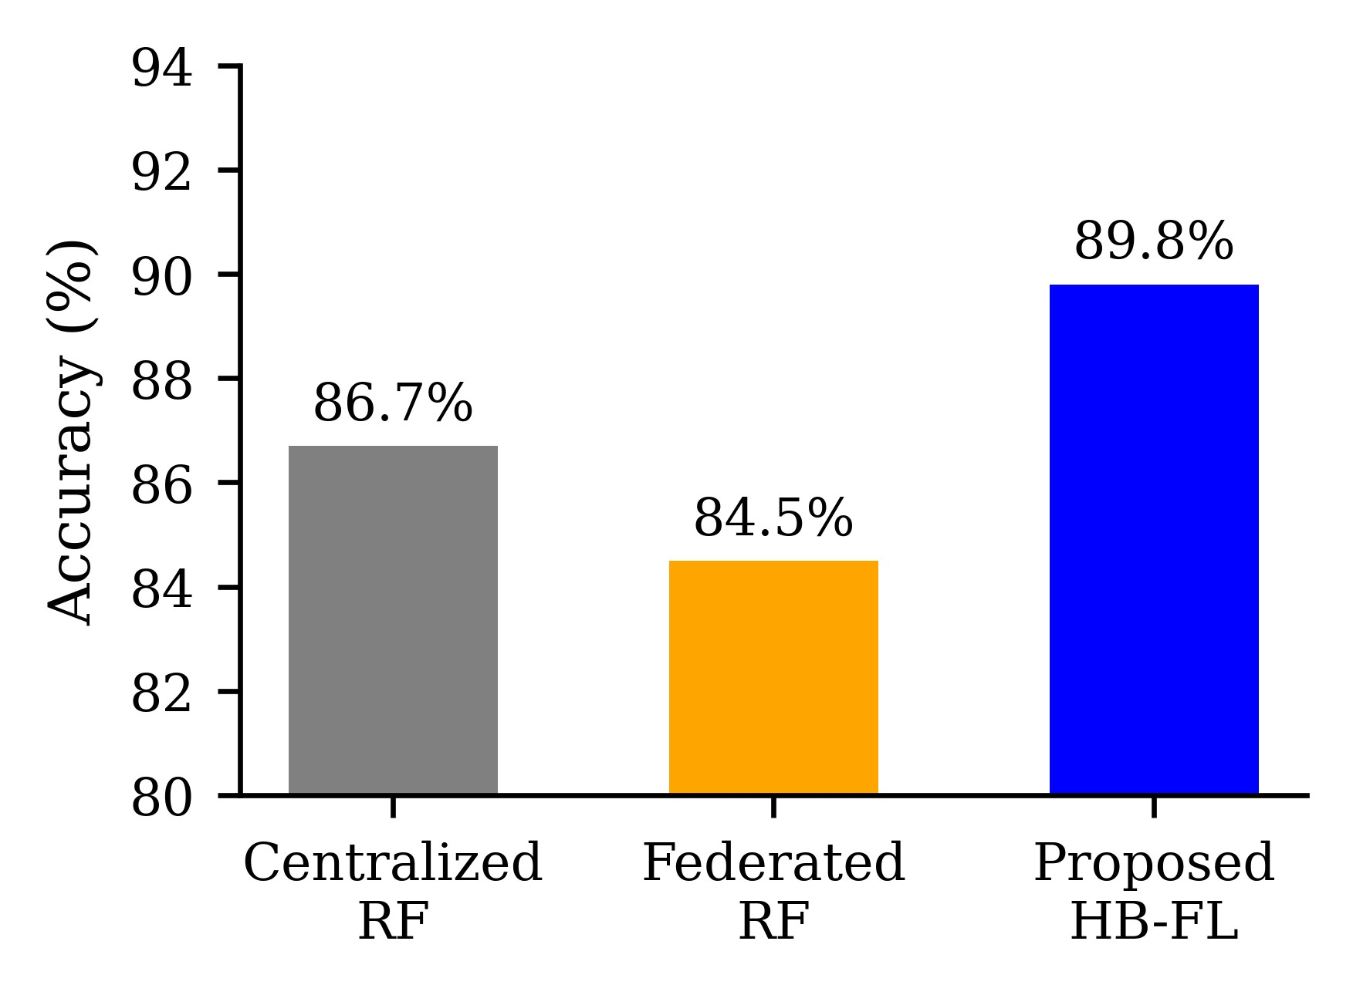
Fig.3. Accuracy comparison of centralized, federated, and proposed HB-FL models.
Table 3. Effect of Reputation Threshold on Model Accuracy and Malicious Client
Detection.
Reputation Threshold | Selected Clients | Global Accuracy (%) | Malicious Clients Detected | False Rejection (%)
0.20 | 25 | 85.1 | 1 | 12
0.35 | 18 | 87.6 | 2 | 8
0.45 | 12 | 89.8 | 3 | 5
0.60 | 8 | 88.3 | 4 | 10
Table 3 highlights the impact of different reputation thresholds on global model accuracy and client reliability.
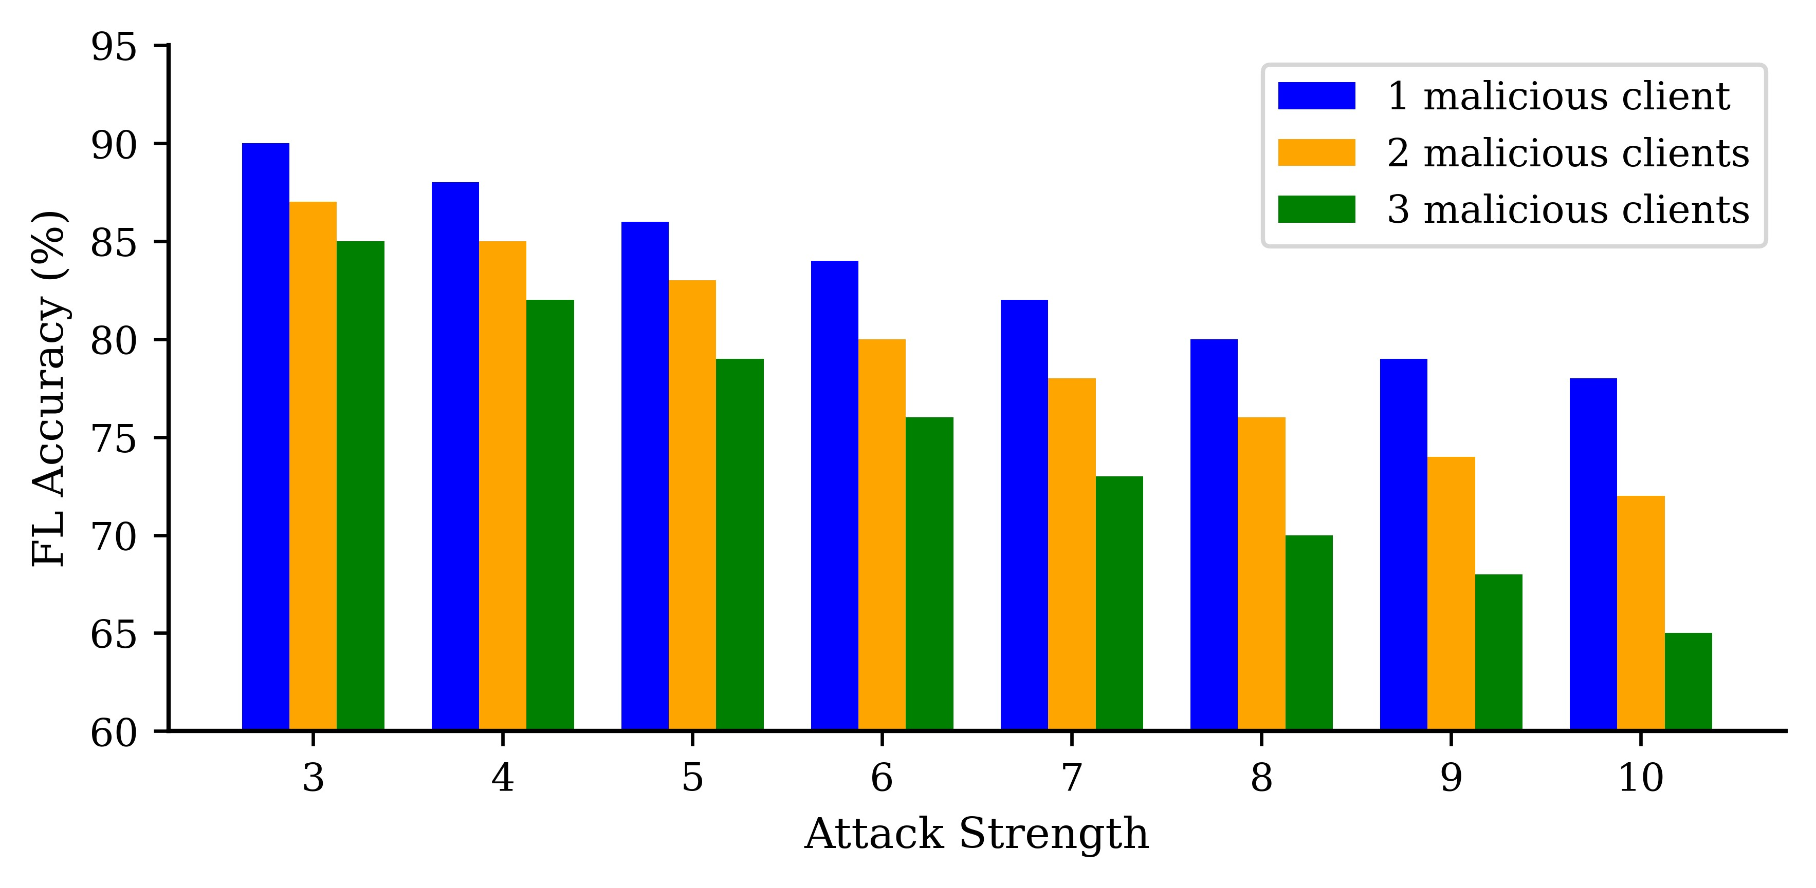
Fig.4. Impact of attack strength and number of malicious clients on federated learning accuracy.
Fig. 4 demonstrates the vulnerability of plain federated learning to malicious updates and how the proposed HB-FL approach mitigates this risk. As the number or strength of malicious clients increases, the accuracy of conventional FL degrades rapidly, showing its sensitivity to poisoned gradients. In contrast, the HB-FL framework maintains a significantly higher and more stable accuracy because the Proof-of-Quality checks and Bayesian reputation scoring effectively detect and down-weight unreliable participants before aggregation. This shows the proposed model’s strong resilience against model poisoning and adversarial behaviors.
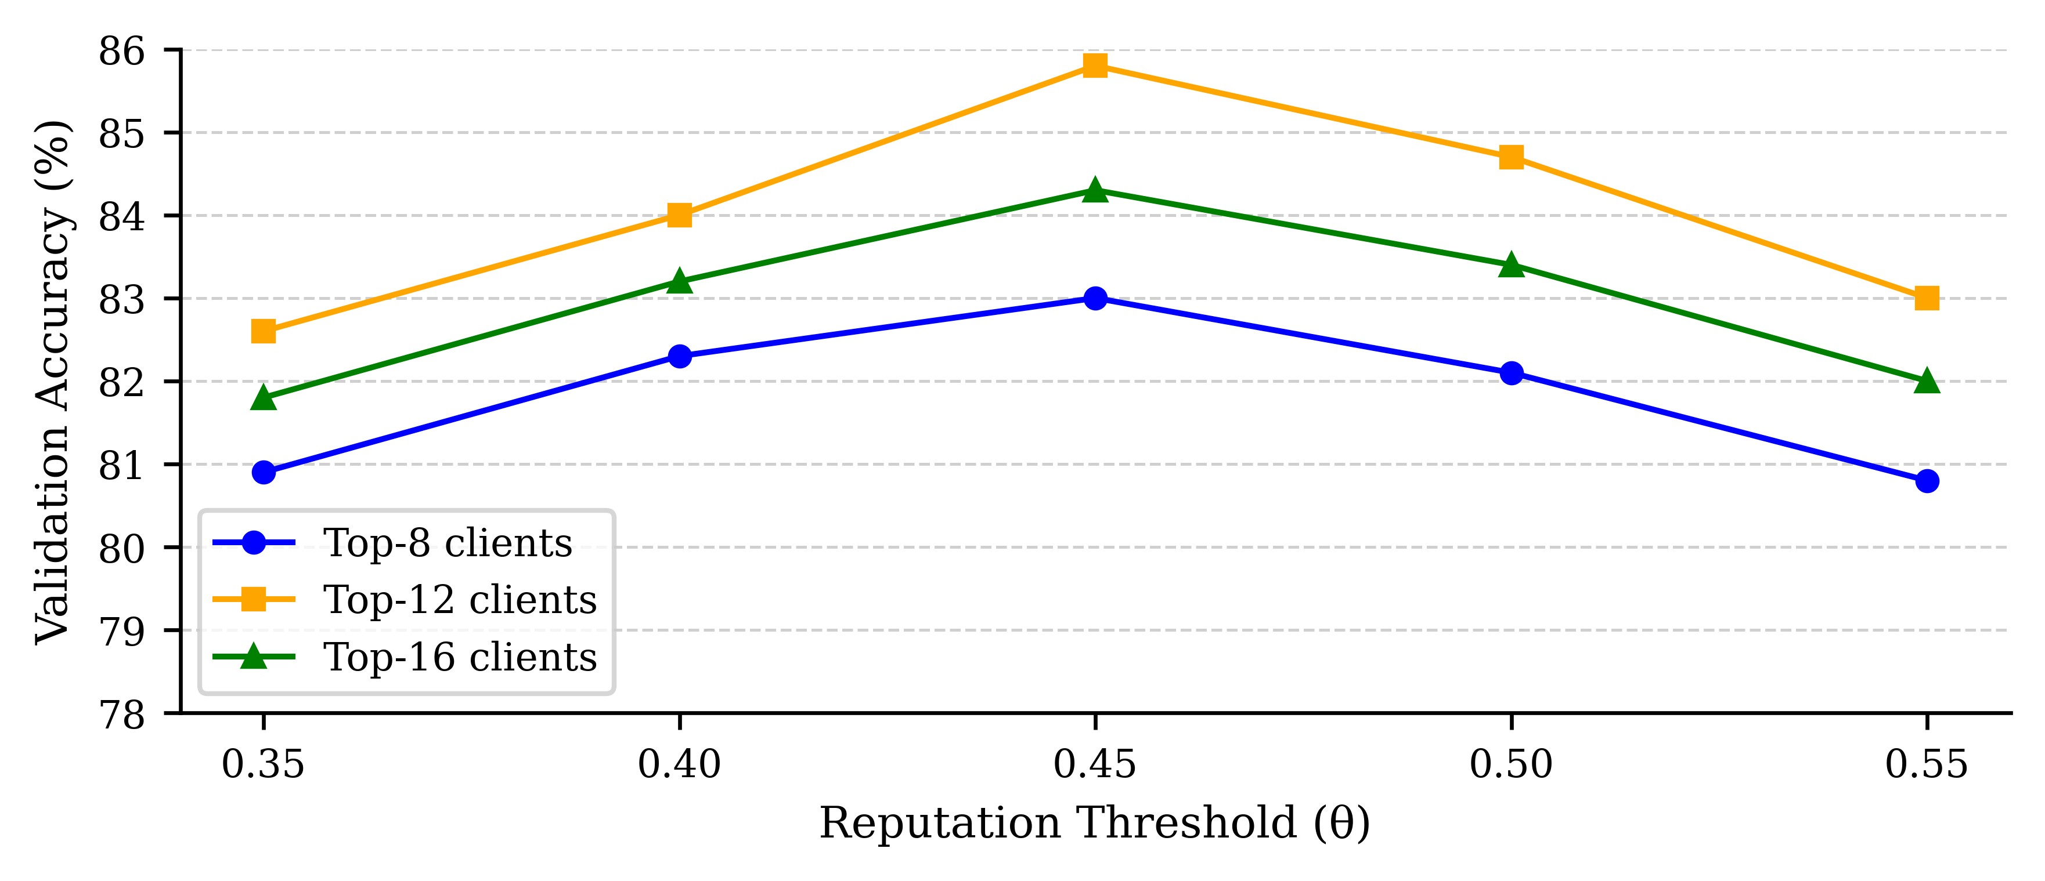
Fig.5. Effect of reputation threshold and client selection on federated learning accuracy.
The analysis in Fig. 5 shows how tuning the reputation threshold and the number of participating clients influences global model performance. A moderate threshold (around 0.45) filters out low-quality contributions while keeping enough diverse data for robust training. Similarly, selecting approximately the Top-12 reputed clients balances diversity and trust, resulting in the most stable and accurate model updates. Too strict a threshold or too few clients may reduce data diversity, while too lenient a threshold may allow malicious updates to slip through. These results guide practical parameter settings for real deployments.
Fig.6. Effect of reputation threshold and client selection on federated learning accuracy.
Fig. 6 shows the proposed HB-FL framework achieving the highest precision (0.90), surpassing centralized RF (0.87) and standard FL without blockchain (0.85). This gain comes from blockchain and reputation mechanisms, improving reliability and reducing low-quality or malicious updates.
Table 4. Computational and Communication Overhead Comparison.
Method | Training Time | Comm. Cost | Security
Centralized Random Forest | 3.2 | 0.5 | None
Federated RF(no blockchain) | 5.1 | 1.8 | Basic FL aggregation only
Proposed(HB-FL+Reputation) | 5.9 | 2.0 | Blockchain ledger+PoQ+Reputation
Table 4 compares computational and communication overhead. Although the proposed HB-FL framework adds slight training and communication cost due to PoQ validation and blockchain anchoring, it greatly improves trust and security through Bayesian reputation scoring and tamper-evident records over conventional FL and centralized methods.

Conclusion
This paper presented a hierarchical blockchain-enabled federated learning framework for heart disease prediction that integrates Proof-of-Quality validation and Bayesian reputation modeling. Experimental results demonstrate improved robustness and accuracy under unreliable participants.
However, the framework does not address advanced adversarial threats such as backdoor or membership inference attacks, nor does it implement cryptographic secure aggregation. Future work will focus on integrating privacy-preserving aggregation primitives, large-scale real-world datasets, and formal security proofs.

Declarations
Competing Interests
The authors declare that they have no competing interests.

Funding Information
This research received no specific grant from any funding agency in the public, commercial, or not-for-profit sectors.

Data Availability Statement
The datasets used and analysed during the current study are available from the corresponding author on reasonable request.

References
- Aasheesh: Framingham heart study dataset. Kaggle (2023), _{https://www.kagg} le.com/datasets/aasheesh200/framingham-heart-study-dataset, accessed: 2025-09-15
- Aich, S., Sinai, N.K., Kumar, S., Ali, M., Choi, Y.R., Joo, M.I., Kim, H.C.: Protecting personal healthcare record using blockchain & federated learning technologies. 2021 23rd International Conference on Advanced Communication Technology (ICACT) pp. 109–112 (2021), https://api.semanticscholar.org/CorpusID:
232235893
- Antunes, R.S., da Costa, C.A., Küderle, A., Yari, I.A., Eskofier, B.: Federated learning for healthcare: Systematic review and architecture proposal. ACM Transactions on Intelligent Systems and Technology (TIST) ₁₃, 1–23 (2022), https://api.semanticscholar.org/CorpusID:246531818
- Bebortta, S., Tripathy, S.S., Basheer, S., Chowdhary, C.L.: FedEHR: A federated learning approach towards the prediction of heart diseases in IoT-based electronic health records. Diagnostics 13 (2023), https://api.semanticscholar.org/Corp usID:264073799
- Chen, Y., Yan, L., Ai, D.: A robust secure blockchain-based hierarchical asynchronous federated learning scheme for Internet of Things. IEEE Access ₁₂, 165280–
165297 (2024), https://api.semanticscholar.org/CorpusID:273911158
- Elayan, H., Aloqaily, M., Guizani, M.: Sustainability of healthcare data analysis
IoT-based systems using deep federated learning. IEEE Internet of Things Journal
9, 7338–7346 (2021), https://api.semanticscholar.org/CorpusID:238641985
- Fereidooni, H., Marchal, S., Miettinen, M., Mirhoseini, A., Möllering, H., Nguyen, T.D., Rieger, P., Sadeghi, A.R., Schneider, T., Yalame, H., Zeitouni, S.: SAFELearn:
Secure aggregation for private Federated learning. 2021 IEEE Security and Privacy
Workshops (SPW) pp. 56–62 (2021), https://api.semanticscholar.org/Corpus
ID:233176356
- Fu, Y., Niu, X., Zhou, L., Cai, X., Yu, F.R., Cheng, N., Li, C.: A hierarchical blockchain-enabled secure aggregation algorithm for federated learning in IoV. IEEE Internet of Things Journal 12, 5876–5890 (2025), https://api.semanticscholar. org/CorpusID:273783518
- Gupta, M., Kumar, M., Gupta, Y.: A blockchain-empowered federated learningbased framework for data privacy in lung disease detection system. Computers in
Human Behavior 158, 108302 (2024), https://api.semanticscholar.org/Corp usID:269942489
- Joshi, K., Reddy, G.A., Kumar, S., Anandaram, H., Gupta, A., Gupta, H.: Analysis of heart disease prediction using various machine learning techniques:
A review study. 2023 International Conference on Device Intelligence, Computing and Communication Technologies (DICCT) pp. 105–109 (2023), _{https:}
//api.semanticscholar.org/CorpusID:258451772
- Jyoti, S., Ujma, A., Dipesh, S., Sunita, S.: Predictive data mining for medical diagnosis: An overview of heart disease prediction. International Journal of Computer
Applications 17, 43–48 (2011), https://api.semanticscholar.org/CorpusID:
15916359
- Lakhan, A., Mohammed, M.A., Nedoma, J., Martínek, R., Tiwari, P., Vidyarthi, A., Alkhayyat, A.H., Wang, W.: Federated-learning based privacy preservation and fraud-enabled blockchain IoMT system for healthcare. IEEE Journal of Biomedical and Health Informatics 27, 664–672 (2022), https://api.semanticscholar.org/
CorpusID:248050155
- Rahman, M.A., Hossain, M.S., Islam, M.S., Alrajeh, N.A., Muhammad, G.: Secure and provenance enhanced internet of health things framework: A blockchain managed federated learning approach. IEEE Access ₈, 205071–205087 (2020), https://api.semanticscholar.org/CorpusID:227061853
- Rajagopal, S.M., M., S., Buyya, R.: FedSDM: Federated learning based smart decision making module for ECG data in IoT integrated edge-fog-cloud computing environments. Internet of Things 22, 100784 (2023), https://api.semanticscho lar.org/CorpusID:258154300
- Rajagopal, S.M., M., S., Buyya, R.: Leveraging blockchain and federated learning in edge-fog-cloud computing environments for intelligent decision-making with ECG data in IoT. Journal of Network and Computer Applications ₂₃₃, 104037 (2024), https://api.semanticscholar.org/CorpusID:273492931
- Rajagopal, S.M., Supriya, M., Buyya, R.: Blockchain integrated federated learning in edge-fog-cloud systems for IoT based healthcare applications a survey. ArXiv abs/2406.05517 (2024), https://api.semanticscholar.org/CorpusID:270371 086
- Rieke, N., Hancox, J., Li, W., Milletarì, F., Roth, H.R., Albarqouni, S., Bakas, S., Galtier, M., Landman, B.A., Maier-Hein, K.H., Ourselin, S., Sheller, M.J., Summers, R.M., Trask, A., Xu, D., Baust, M., Cardoso, M.J.: The future of digital health with federated learning. NPJ Digital Medicine ₃ (2020), _{https:}
//api.semanticscholar.org/CorpusID:212747909
- Shynu, P.G., Menon, V.G., Kumar, R.L., Kadry, S., Nam, Y.: Blockchain-based secure healthcare application for diabetic-cardio disease prediction in fog computing.
IEEE Access 9, 45706–45720 (2021), https://api.semanticscholar.org/Corpus
ID:232413961

